CSA1509-Cloud computing and big data analytics
Experiment-5
Create a simple cloud software application for Result Processing System using
any Cloud Service Provider to demonstrate SaaS include the necessary fields such as
name of the learner, Reg no of the learner , Subjects , Marks, Average, percentage,
rank, overall performance etc.
Input
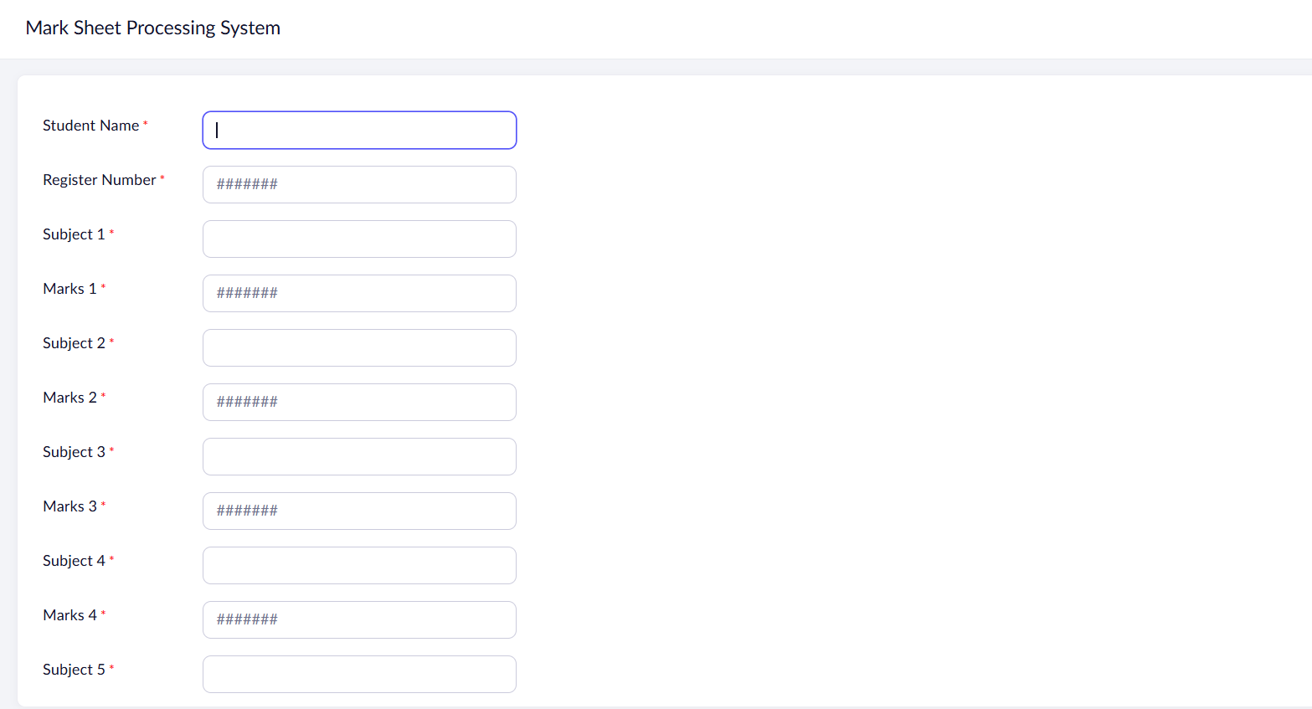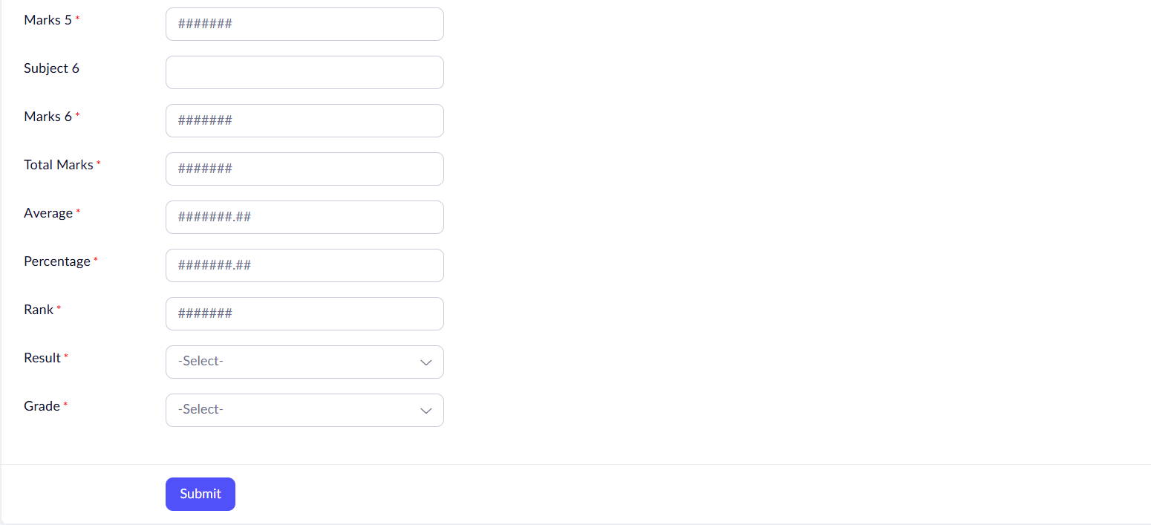
Output
